Current Coverage:
But AWS and Azure cloud connectors alone cannot discover all eight families from the research. They cover cloud-control-plane artifacts; source code, endpoint, SaaS/browser, and richer identity/data evidence need separate discovery planes.
Research artifact family | Current coverage | Main gap
Apps & copilots | Partial | Azure Bot Services/channels and Bedrock-agent-adjacent Lambda are found. SaaS copilots, browser usage, and deployed app workloads are not.
Agents & orchestration | Partial | Bedrock Agents, action-group Lambda links, and preview-gated Foundry agents/tools are covered. No ECS/EKS/runtime orchestration, agent traces, approval gates, or memory.
MCP components | None | No MCP manifest, server/tool, OAuth client, consent, or local config discovery.
Models & weights | Partial | Bedrock model references, Foundry deployments, Azure ML models/endpoints/deployments are found. No SageMaker inventory, model provenance, import lineage, signatures, model cards, or ML-BOMs.
Data & retrieval | Partial | Bedrock Knowledge Bases and their S3 links; Azure AI Search service shell. Azure Search index/skillset/indexer/data-source discovery is explicitly unsupported pending least-privilege certification. No vector-store, RAG source, or data-classification inventory.
Software & infrastructure | Limited | Lambda and Azure ML compute are observed. No EKS/ECS/container/notebook/IaC/code relationship inventory.
Identities & credentials | Partial | Bedrock execution roles and wildcard-policy evidence; Azure managed identities and subscription role assignments. Missing AWS trust policies/cross-account paths, Azure service principals/federated credentials, OAuth, secrets, and effective permissions.
Governance & telemetry | Partial | Bedrock invocation-logging setting, Azure diagnostic settings, Azure RAI policies, and relationships are captured. No prompt/tool event ingestion, audit-log correlation, evaluations, model cards, or ML-BOM evidence.
What the connectors already discover:
- AWS: Bedrock Agents, referenced models, knowledge bases, S3 source exposure, guardrails, invocation-logging configuration, action-group Lambda URLs, and execution-role wildcard-policy evidence. [AWS discovery service](/Users/gowrikarthik.gadela/Desktop/AI Projects/NoScan/prototype-app/backend/src/main/java/com/prototype/vulnwatch/aisecurity/aws/AwsBedrockDiscoveryService.java)
- Azure: AI accounts, Foundry projects/deployments/RAI policies, optionally preview Foundry agents/tools, Azure ML workspaces/models/endpoints/deployments/compute/jobs/pipelines, AI Search services, Bots/channels/managed identities, diagnostics, and RBAC assignments. [Azure connector families](/Users/gowrikarthik.gadela/Desktop/AI Projects/NoScan/prototype-app/backend/src/main/java/com/prototype/vulnwatch/aisecurity/azure/AiSecurityAzureConnectorService.java)
Important Azure caveats: Foundry agent discovery is off by default, and the Search data-plane families are deliberately returned as UNSUPPORTED until a definition-only custom role is certified. This is a good safety boundary, but it is an inventory gap. [Azure discovery behavior](/Users/gowrikarthik.gadela/Desktop/AI Projects/NoScan/prototype-app/backend/src/main/java/com/prototype/vulnwatch/aisecurity/azure/AzureAiDiscoveryService.java)

Recommended stealth-mode plan:
- Inventory integrity first — 2–3 weeks
Add a per-provider/family coverage manifest: discovered, unsupported, permission-denied, or not-applicable. Seed breadth with AWS Config/Resource Explorer and Azure Resource Graph, then enrich identified AI resources with existing provider APIs. This prevents “zero artifacts” from looking like “no AI.”
- Close the highest-value cloud gaps — 4–6 weeks
Add AWS SageMaker inventory: domains/workspaces, model registry/packages, endpoints/configurations, jobs/pipelines, compute, and linked roles/networking. Extend Bedrock for its remaining deployable model, prompt/flow, and inference resources. On Azure, certify AI Search definition-only access and enable Foundry-agent discovery behind a feature flag.
- Add relationship depth, not raw document collection — 3–4 weeks
Collect metadata-only links: model ↔ deployment ↔ agent ↔ tool ↔ identity ↔ data source. Do not read prompts, documents, model weights, API keys, or Search documents. This provides the attack-surface graph while preserving least privilege.
- Fill the non-cloud planes — 6–10 weeks
Extend the existing GitHub connector to detect AI SDKs, MCP manifests, notebooks, IaC, and CI declarations. Add Kubernetes/ECS workload inventory, then a separate IdP/IAM connector for service principals, managed identities, OAuth clients, and effective grants.
- Make shadow AI and runtime telemetry opt-in
Add proxy/CASB/browser and guardrail/SIEM telemetry only after customers approve the data boundary. Store event metadata and aggregation first; avoid collecting prompt content by default.
For stealth mode, ship each family behind tenant feature flags, use read-only roles, record explicit coverage receipts, and expose the first UI as “AI inventory preview” to design partners only. The near-term success metric should be coverage completeness by account/subscription and family—not number of findings.

Step 1 - AI Inventory Pilot - ‘DoD’:

- Both connectors authenticate using read-only workload identities.
- Discovery runs complete across the approved regions with no cloud writes.
- The AI Inventory screen shows discovered AWS/Azure artifacts and relationships.
- Any failed, partial, or unsupported discovery scope is visible—not hidden as an empty result.
- Azure AI Search data-plane and Foundry-agent preview gaps are explicitly marked unsupported unless certified/enabled.
- A second run produces no duplicate artifacts or relationships.
- A sampled set of results matches the AWS/Azure consoles.
- You have a short private evidence report with:
  - accounts/subscriptions and regions scanned;
  - artifact and relationship totals by provider/family;
  - missing permissions and unsupported families;
  - defects fixed;
  - the next prioritized inventory slice—AWS SageMaker.
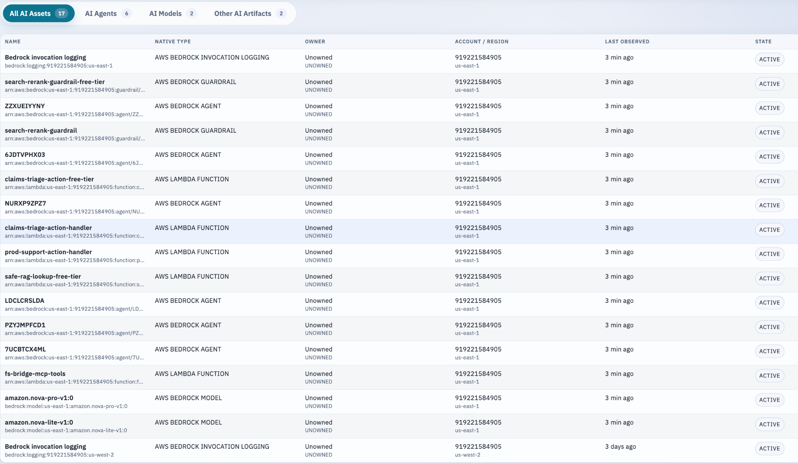

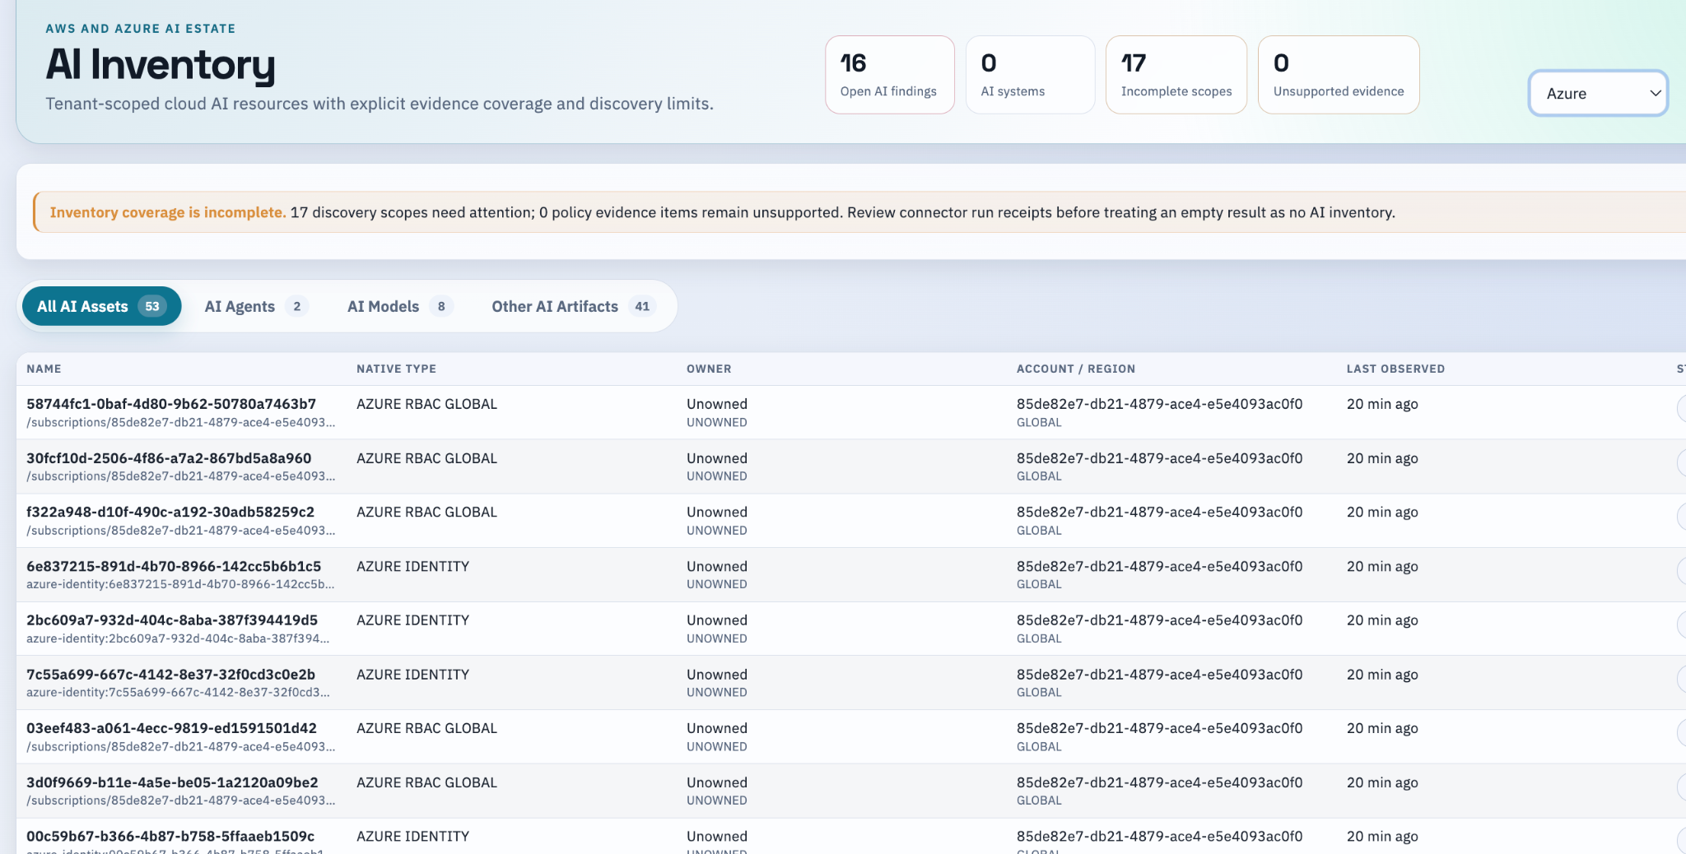

Step 2 - Managed AI Inventory Expansion - DoD:

Definition of Done for the next phase:
- AWS SageMaker discovery is implemented and pilot-validated for domains/spaces, model registry/packages, endpoints/configurations, jobs/pipelines, compute, execution roles, and networking links.
- Bedrock discovery includes deployable/custom/imported/provisioned models, inference profiles, customization jobs, prompts, and flows.
- Every new family produces either:
  - stable artifacts and relationships with a COMPLETE scope, or
  - an explicit PARTIAL, FAILED, or UNSUPPORTED scope with the missing read permission/API reason.
- Two consecutive AWS pilot scans complete without duplicate artifacts and with stable identities.
- Azure AI Search definition-only inventory discovers indexes, skillsets, indexers, and data sources when its feature flag is enabled; evidence confirms it never reads documents, search results, keys, connection strings, or secrets.
- Foundry-agent and tool inventory works when its feature flag is enabled and remains unavailable by default.
- The AWS IAM policy and Azure custom role are reviewed and applied by an authorized account owner; connector tests pass with those least-privilege permissions.
- A sampled console reconciliation confirms every expected pilot artifact is represented in Scout, or any absence is recorded as an incomplete/unsupported scope.
- The scope-details API shows actionable diagnostics for all failed AWS/Azure scopes.
- The evidence pack is saved: policy versions, connection tests, scan IDs, scope statuses, artifact counts, API-call totals, idempotency results, and reconciliation notes.
- No Azure resources are created, changed, started, or provisioned at any point without your explicit approval.
Step 2 is completed
AWS Coverage:
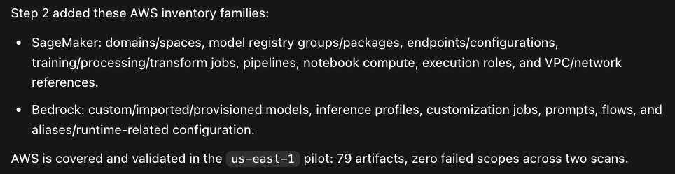

AWS is validated

Azure Coverage:
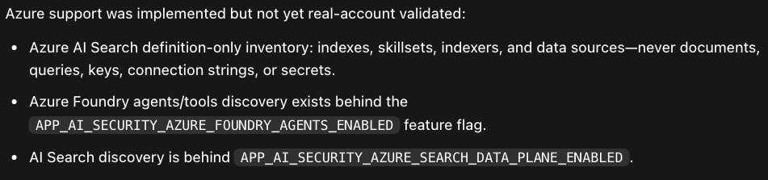

Azure is yet to be validated

Step 3 — Metadata-Only AI Relationship Graph - DoD
Scout can reliably show the metadata-only attack-surface path:
model → deployment → agent → tool → identity → data source
with these conditions met:
- AWS us-east-1 pilot discovers and persists direct relationships for Bedrock and SageMaker, including model/deployment, agent/tool, IAM role, and network/data references.
- Every edge is labeled DIRECT or INFERRED, includes safe source evidence, and has a stable identity across two scans.
- The existing artifact-detail and graph views display those links, filters, and evidence without showing sensitive configuration.
- Scout never collects or exposes prompt bodies, documents, Search results, model weights, API keys, secrets, connection strings, or object contents.
- Two read-only scans return stable artifact/edge counts with no duplicates and clear COMPLETE / PARTIAL / ACCESS_DENIED / UNSUPPORTED scope status.
- A sample of real AWS console resources reconciles exactly to Scout’s graph paths.
- Azure Foundry/Search relationship discovery is implemented behind its existing feature flags, passes definition-only contract tests, and remains off until read-only Azure validation succeeds.
- The evidence pack contains policy versions, enabled flags, artifact/edge counts, API-call totals, scan IDs, scope diagnostics, and reconciliation results.
- No cloud resources, permissions, model invocations, jobs, or endpoints were created or changed by Scout during validation

Step 3 is complete for the current pilot scope.
- AWS: completed and validated with real metadata.
- Azure Search: Step 3 feature-gated definition discovery completed across two stable scans.
- Azure scan results: 47 artifacts on both scans; all AI Search definition families (indexes, skillsets, indexers, data sources) completed read-only.
- Azure Foundry-agent discovery is now correctly treated as UNSUPPORTED_API_VERSION when the preview endpoint returns 404, rather than an ambiguous provider failure.
- Scout now derives enabled Step 3 Azure families from the explicit feature flags at scan time, so it no longer depends on the blocked local connector-save path.

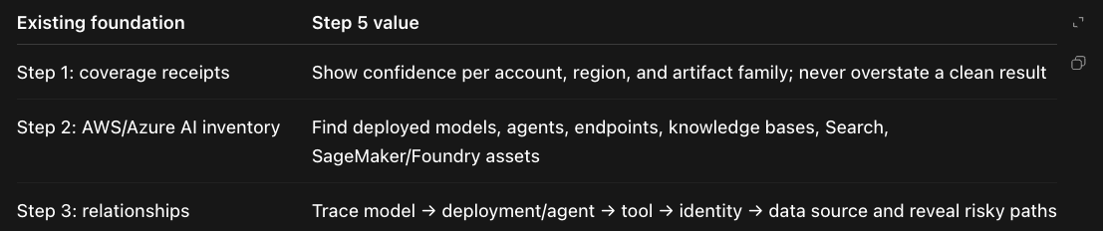

Step 4: Fill the non-cloud planes — DEFERRED
Extend the existing GitHub connector to detect AI SDKs, MCP manifests, notebooks, IaC, and CI declarations. Add Kubernetes/ECS workload inventory, then a separate IdP/IAM connector for service principals, managed identities, OAuth clients, and effective grants.
Step 4 is done when a design partner can run the new connectors and answer:
- Which repositories declare AI SDKs, MCP servers, notebooks, AI-related IaC, or CI workflows?
- Which EKS, AKS, and ECS workloads run those components, with image and workload-identity links?
- Which Entra service principals, managed identities, OAuth clients, and AWS IAM roles can access those workloads or AI resources?
- What coverage is missing because of permissions, unreachable clusters, or unsupported evidence?
Concrete Definition of Done:
- GitHub code connector scans allowlisted repos and produces metadata-only AI artifacts and graph links; it never stores source content, notebook cells, secrets, prompts, or environment values.
- EKS/AKS in-cluster agent inventories workload metadata through a read-only service account; ECS inventory works through AWS APIs.
- Identity connector inventories Entra and AWS IAM principals plus explainable declared-effective grants, with documented limits for PIM, Conditional Access, and runtime policy simulation.
- All new discovery families return explicit COMPLETE, PARTIAL, FAILED, or UNSUPPORTED receipts—an empty result never implies “no assets.”
- AI Inventory UI shows repository, workload, and identity artifacts, their relationships, connector health, and coverage gaps.
- Each plane is behind a tenant feature flag and uses published least-privilege, read-only permissions.
- Automated unit, client-contract, RLS/isolation, correlation, redaction, and partial-failure tests pass.
- A pilot tenant successfully runs all enabled connectors and verifies representative paths such as: GitHub declaration → deployed workload → workload identity → AI resource/grant.

Step 5: AI Exposure Intelligence Pilot
1st release Target: AI Inventory Overview + enriched AI Exposures + asset-level control posture, using the existing Policies and Connect screens as drill-downs
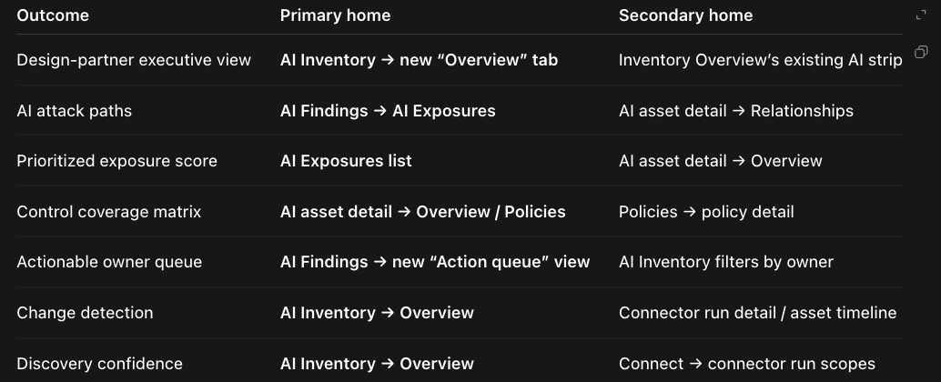
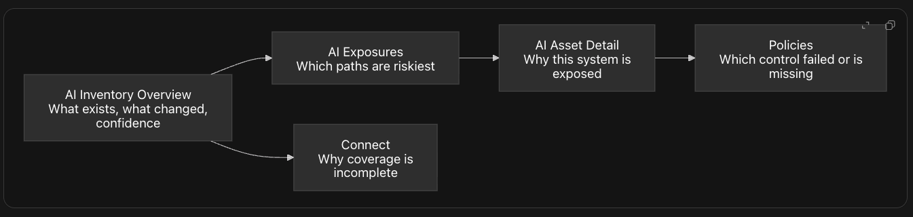
Step 5 is done when an AI Security design partner can open AI Inventory → Overview and reliably answer:
- What cloud AI systems do we have?
- Which validated AI exposure paths matter most?
- Who owns the remediation?
- How confident is ScoutGrid’s coverage?
- What materially changed since the last authoritative scan?
Acceptance criteria:
- Executive Overview displays AI estate count, validated critical/high exposures, top remediation priorities, ownership distribution, coverage confidence, and material changes.
- Only COMPLETE discovery scopes contribute to executive risk and change metrics; partial, failed, and unsupported scopes are visibly called out.
- Every validated exposure has an explainable 0–100 priority score with severity, confidence, public exposure, criticality, and recency factors.
- AI Exposures supports filtering by owner, provider, system, severity, confidence, and priority, and clearly labels hypotheses versus validated paths.
- AI Findings includes an owner-grouped Action Queue containing only open deterministic findings and validated exposure findings.
- Each queue item links to evidence, affected AI system, owner, and recommended remediation breakpoint.
- AI Asset Detail shows a control-posture summary: observed controls, failures, missing evidence, unsupported evidence, and connected exposure paths.
- Policies show assurance coverage and decision-readiness by provider/account, including why a policy cannot evaluate.
- Inventory changes show added, removed, or materially changed AI artifacts, relationships, and validated exposures since the last authoritative epoch.
- All new APIs and UI paths enforce tenant isolation and existing AI Security entitlement/feature-flag gating.
- Tests pass for scoring, authoritative-scope handling, change detection, queue eligibility, API filtering, UI navigation, and no sensitive-content persistence.
- No prompts, model responses, source-code bodies, secrets, credentials, notebook cells, or runtime payloads are collected or shown.

Demo Relationship & Policy Validation Test Bed
Repeatable end-to-end demo environment across AWS and Azure.
- Dedicated, clearly tagged AWS us-east-1 and Azure eastus2 fixture scopes exist, with automatic teardown in seven days.
- No production data, prompts, documents, API keys, connection strings, or customer identities are used.
- Both secure and intentionally weak demo configurations exist and are isolated from real workloads.
- AWS discovery shows stable paths such as:
  - model → agent → Lambda/tool → role
  - flow → execution role
  - SageMaker model package → package group
- Azure discovery shows stable paths such as:
  - deployment → Foundry agent → tool → managed identity
  - Search indexer → data source → skillset → index
- Two scans per provider produce stable artifact and relationship IDs with no duplicates.
- Secure fixtures generate no related policy findings; labeled weak fixtures generate only the expected policy findings.
- Scout demonstrates that it never reads or exposes prompt content, documents, Search results, object contents, API keys, connection strings, secrets, or model weights.
- The evidence pack includes scan IDs, artifact/edge counts, policy results, scope status, API-call budgets, applied permission versions, screenshots or console reconciliation, and teardown verification.
- No recurring-cost resources are left running: no SageMaker endpoint/notebook/training job, Bedrock provisioned throughput, or Azure provisioned model capacity.
- 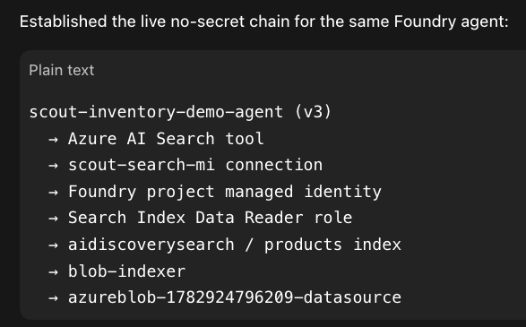

Policy Framework Enhancement Plan
DOD:
The enhancement is complete when:
- platform.ai_grid_policy_versions is the single authoritative policy catalog for evaluation, platform controls, tenant policy pages, asset details, and findings.
- New policies are created from versioned Git policy packages—not Java registry entries or direct production database edits.
- Every package is linted for fact/type/evidence compatibility, bounded predicate validity, framework mapping format, required metadata, and immutable version rules.
- A platform owner can import a draft, view validation and impact preview, approve it independently, canary it, publish it, control distribution, pin/roll back versions, and retire it.
- High/Critical policies cannot publish without certified answer-key tests and a passing dual-reviewed precision review.
- Catalog lifecycle, platform distribution, tenant selection, evidence readiness, and evaluation decision are represented separately and visible in APIs/UI.
- Preview policies evaluate coverage and readiness but do not create normal customer-facing findings.
- Tenant admins can only enable/disable eligible distributed policies; they cannot create policies, edit predicates, or bypass required controls.
- Existing legacy policies and tenant settings migrate to the governed catalog with reconciled IDs, selections, historical finding provenance, and no unexpected change in effective tenant behavior.
- The Java AiSecurityPolicyRegistry, legacy distribution reads, and policy-specific evaluator logic are no longer used in the normal policy path.
- Policy Studio shows OWASP LLM Top 10 coverage, unmapped categories, policy lifecycle, evidence maturity, and candidate backlog priority.
- The initial catalog has 18 governed policies, with 12–14 default-enforced controls and remaining lower-confidence controls in Preview.
- Automated tests cover package validation, evaluation decisions, missing/stale evidence, typed parameters, approvals, canary/publish/rollback, tenant permissions, migration reconciliation, and Preview non-finding behavior.
- Release documentation identifies how a platform owner ships a policy, how a tenant consumes it, and how an unsafe or inaccurate release is rolled back.

The target operating model
A platform owner controls shipment at two distinct layers:
- Catalog release: Is a specific immutable policy version safe and valid enough to publish?
- Distribution: Which tenants can see it, which cohorts receive it in Preview/Canary, and whether it becomes default-enabled.
PUBLISHED should mean “platform-approved and operationally safe.” It should not automatically mean “enabled for every customer.”

How a policy should be defined
Treat each policy as a versioned policy package managed in source control and compiled into the platform catalog—not as an ad hoc database row or customer-facing rule script.
Each package should contain:
- Stable policy ID, semantic version, owner, status, changelog, replacement/deprecation link.
- Security outcome and threat rationale.
- Applicability: provider, technology, artifact/native kind, resource family, required connector capabilities.
- Evidence contract: required facts, types, acceptable evidence classes, minimum confidence, maximum age, required corroboration.
- Bounded declarative predicate.
- Severity, workflow class, reason codes, remediation, framework mappings.
- Tenant-selection recommendation: required / enabled / preview / disabled.
- Answer-key scenarios: secure, insecure, missing evidence, stale evidence, proxy-vs-verified, permission-incomplete.
- Expected reach, expected decision-readiness, false-positive risk, and rollout notes.
The existing governed catalog schema is close to this; it needs the package/source-control workflow and a few missing release fields rather than a new policy engine.

How you decide what policies to add
Do not build a large policy catalog because competitors have one. Add a policy only when it passes this intake gate:
Question | If “no”
Is there a concrete AI security/control objective? | Reject or keep as research
Can NoScan collect authoritative evidence for it? | Create a connector/coverage backlog item, not a policy
Can the result drive a clear customer action? | Improve the use case before shipping
Can it be tested with answer-key cases? | Keep in draft
Is expected false-positive cost acceptable? | Preview/Canary only
Does it have meaningful reach across target customers? | Deprioritize unless strategically required
Prioritize candidates with a simple portfolio score:
Customer risk × asset reach × evidence maturity × remediation clarity
This creates a disciplined backlog sourced from:
- Findings with recurring coverage gaps or repeated unsafe configurations.
- New connector capabilities—the moment you can reliably discover an AI asset/evidence type, evaluate its associated controls.
- Threat intelligence, cloud-provider feature changes, OWASP LLM risks, NIST AI RMF, CIS, and customer contractual controls.
- Design-partner requests, but only when they become reusable platform controls.
- Incidents and postmortems.
A useful rule: if NoScan cannot distinguish “unsafe” from “unknown because evidence is incomplete,” it is not ready to ship as an enforcement policy. It belongs in coverage/setup guidance or Preview.

Recommended platform-owner experience
Build a platform-only Policy Studio. It should not be a free-form customer query builder.
The owner sees:
- Candidate backlog — proposed policies, source signal, affected resource families, evidence maturity and estimated reach.
- Definition — the policy package and evidence contract.
- Validation — lint errors, unsupported facts, answer-key status, required precision review.
- Impact preview — how many current candidates would be applicable, ready, NO_DECISION, pass, or fail; and what changes versus the currently published version.
- Release controls — approve, canary cohort, publish, distribute, pin, rollback, retire.
- Catalog health — policies by technology, evidence readiness, decision rate, false-positive rate, coverage gaps, and stale definitions.

